NAME:-MUNAGAPATI.BHARGAV

REGISTERED NUMBER:-192111375

SUBJECT:-SOFTWARE ENGINEERING WITH AI TECHNIQUES

SUBJECTCODE:-CSA1OO1

FACULTY:-DR.G.MARY VALANTINA

EXPERIMENT-18

DATE:-29-09-2022

AIM:- To draw ACTIVITY DIAGRAM diagram for ONLINE RAILWAY RESERVATION SYSTEM using umbrello

DIAGRAM:-

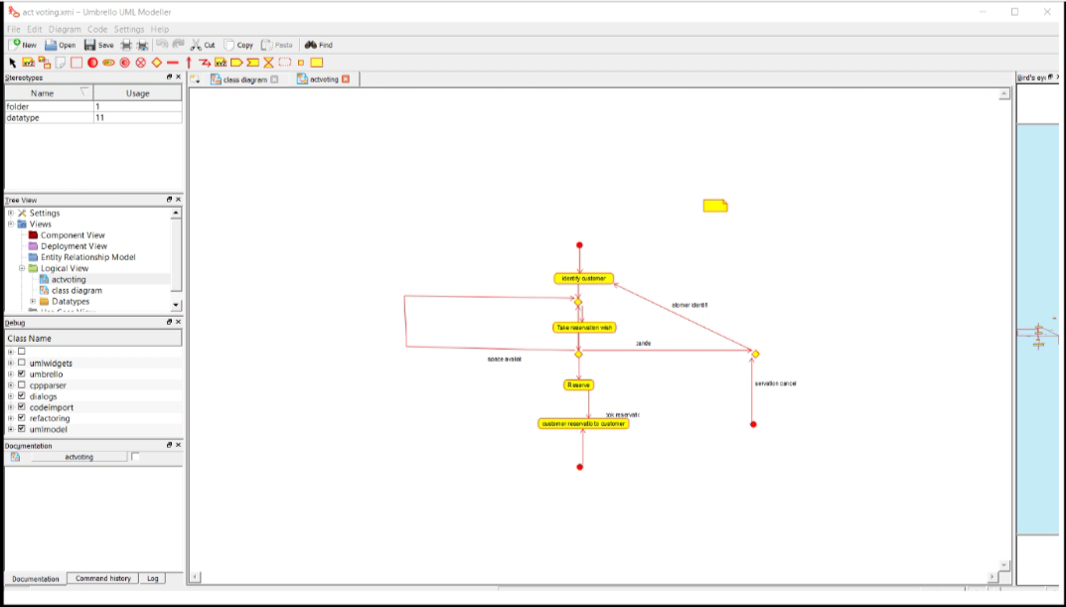

RESULT:- SSuccessfully done the ACTIVITY DIAGRAM of ONLINE RAILWAY RESERVATION SYSTEM in umbrello software

EXPERIMENT-21

DATE:-29-09-2022

AIM:- To draw FLOWCHART DIAGRAM diagram for FIBINOCCI SERIES using RAPTOR

DIAGRAM:-

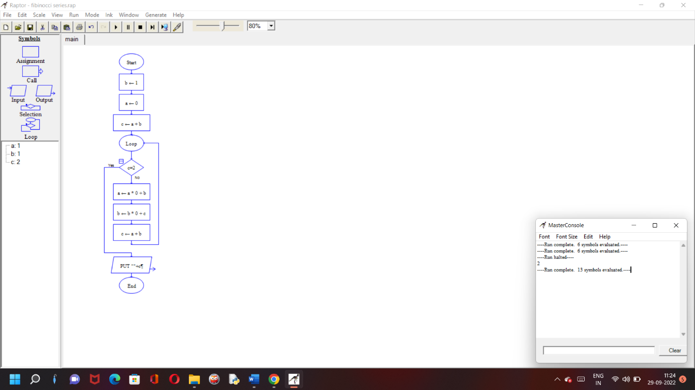

RESULT:- SSuccessfully done the FLOWCHART DIAGRAM diagram for FIBINOCCI SERIES using RAPTOR

EXPERIMENT-22

DATE:-29-09-2022

AIM:- To draw FLOWCHART DIAGRAM diagram for SWAP OF TWO NUMBERS using RAPTOR

DIAGRAM:-

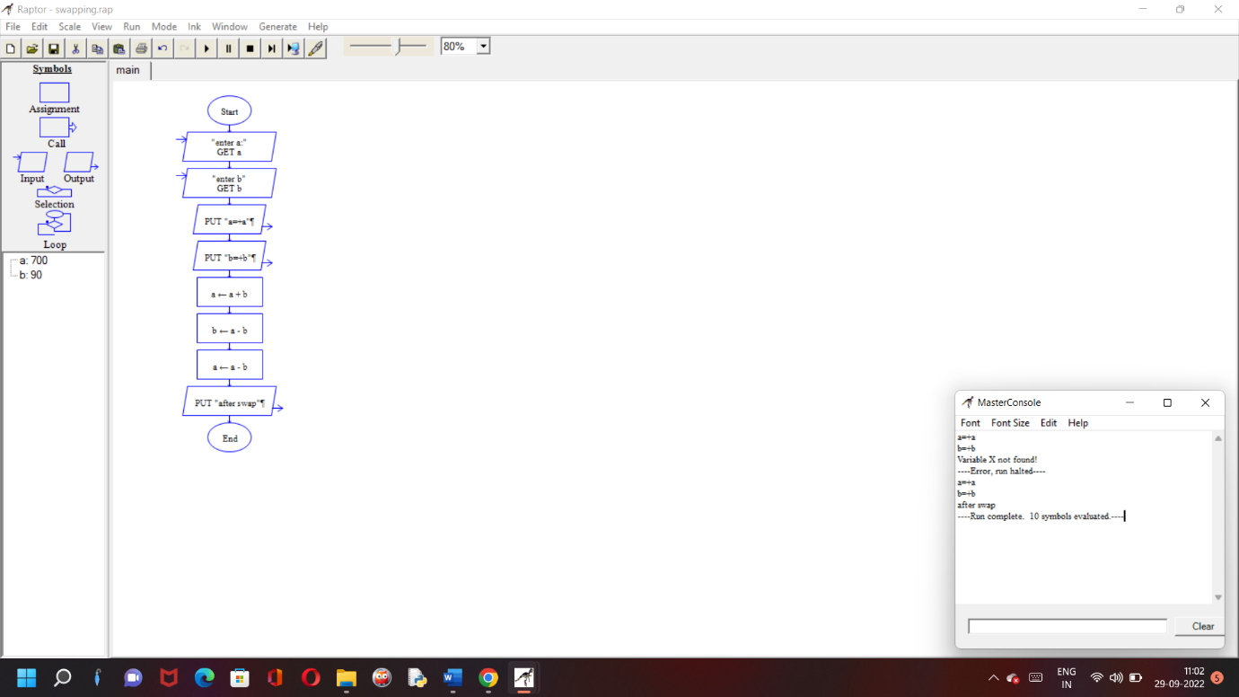

RESULT:- SSuccessfully done the FLOWCHART DIAGRAM for SWAP OF TWO NUMBERS using RAPTOR

EXPERIMENT-23

DATE:-29-09-2022

AIM:- To draw FLOWCHART DIAGRAM for LENGTH OF STRING using RAPTOR

DIAGRAM:-

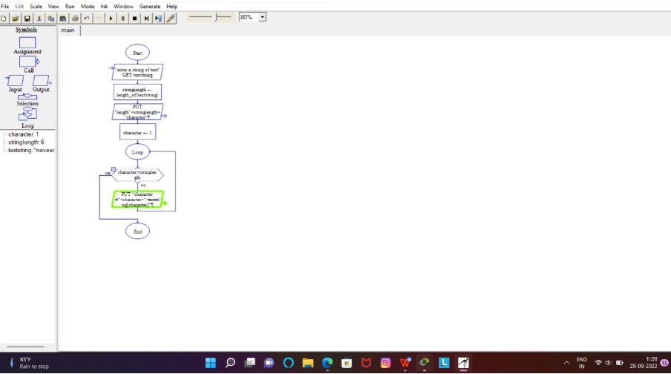

RESULT:- SSuccessfully done the FLOWCHART DIAGRAM for LENGTH OF STRING using RAPTOR

EXPERIMENT-24

DATE:-29-09-2022

AIM:- To draw FLOWCHART DIAGRAM for PRIME OR NOT using RAPTOR

DIAGRAM:-

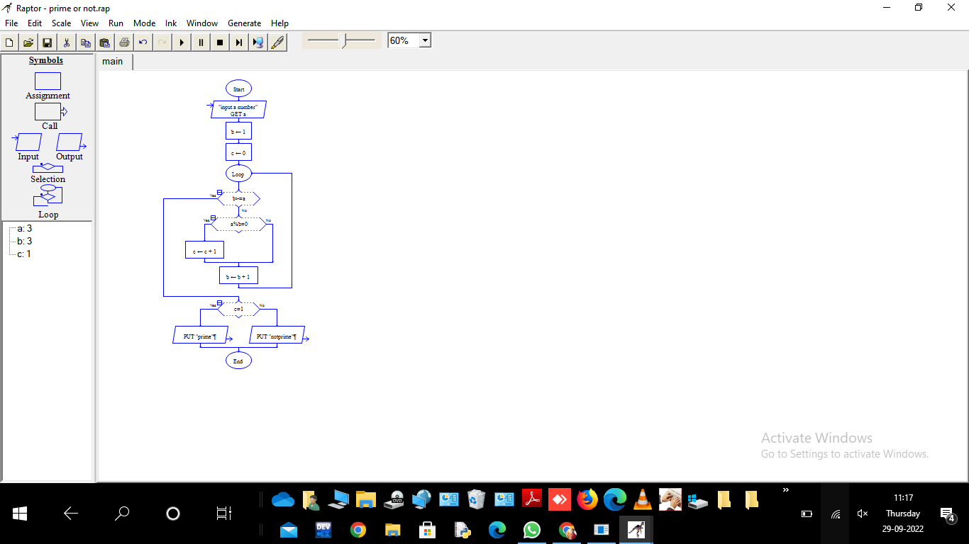

RESULT:- SSuccessfully done the FLOWCHART DIAGRAM for PRIME OR NOT using RAPTOR